W548D-How to setup it in DSL mode?
Product line: ADSL Question category: Internet Setting
I. Physical connection:
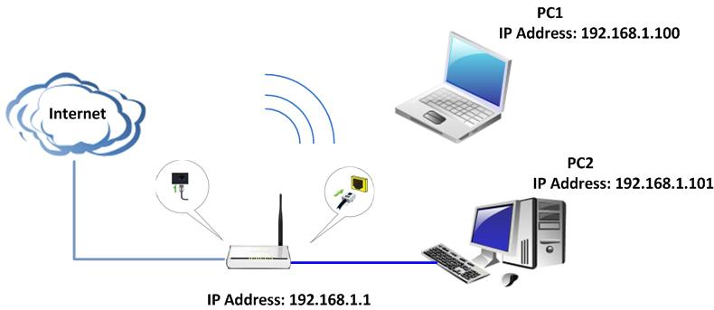
1. Connect the telephone line to the DSL port of the router.
2. Take an Ethernet cable to connect your computer with one of the yellow LAN port (1, 2, 3 or 4) of the router.
3. Check the LED lights. Making sure Power is on, the LAN port which you have plugged the cable in is on, the ACT, ADSL and WLAN are on or blinking.
Note: If you can access internet through W548D after setting, the ADSL light should be always on.

II. Login to the management page of the router:
1. Open a web browser (IE, Firefox, Safari, etc.) and find the address bar, leaving it blank before typing in 192.168.1.1, and then press enter.
(Care: The address bar is in the most top of the web page after opening web browser).
2. Input the default user name and password: admin in the following pop-up window, then click on OK.
3. Click on system mode on the main menu and then check DSL Uplink and click on apply. It will reboot if you change the mode form Ethernet Uplink.
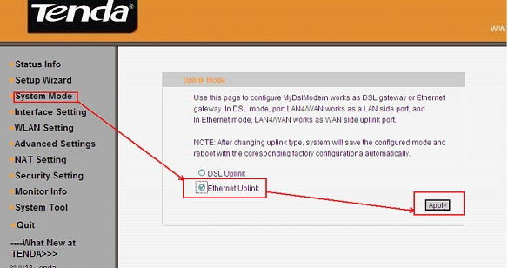
4. Then go to Setup Wizard and select your Country Name and Area Name, typing in VPI/VCI which is from ISP (Internet Service Provider), and then click on next.
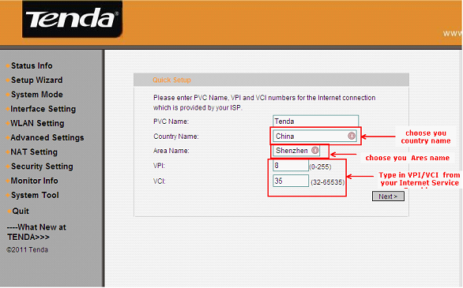
5. Then select your internet access mode. If you don’t know, please ask your ISP. When you have selected the right mode, just click on next.
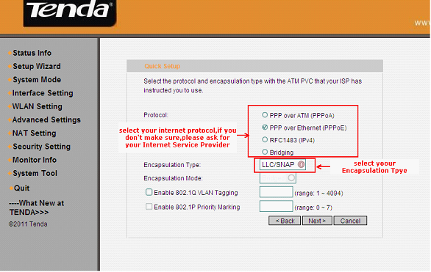
PPPOA or PPPOE click here.
RFC1483 click here.
Bridging click here.

5.1 If you choose PPPOE or PPPOA, you will see the following page. Select the correct access mode and click on next and then click on apply at the next page.
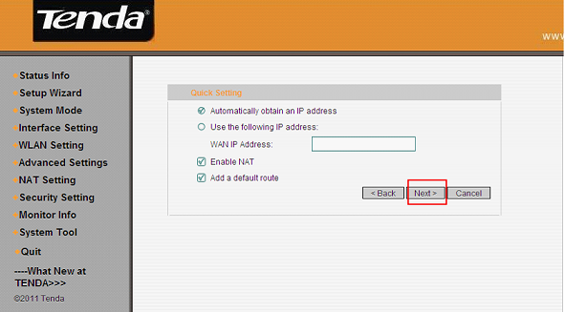
Type in the username and password provided by your ISP in the following page, and then click on next and click on apply at the next page. Then click here.
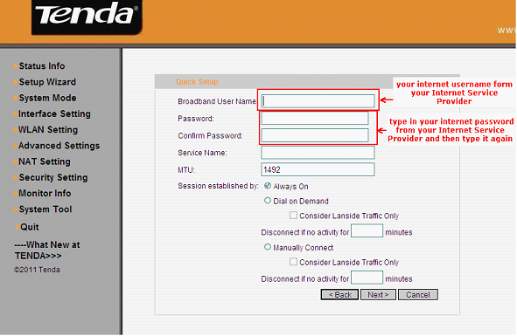
5.2 If you choose RFC1483 (IPv4), you will see the following page. Select the correct access mode and click on next and then click on apply at the next page. After that, please skip to 5.4.

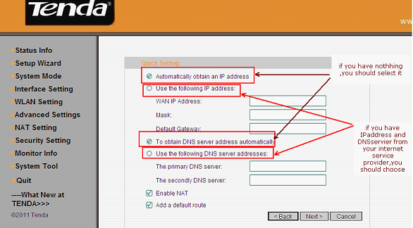

5.3 If you choose Bridging, typing in the information in this following page. Don’t forget to click on next and click on apply at the next page. When finished, please go to 5.4.

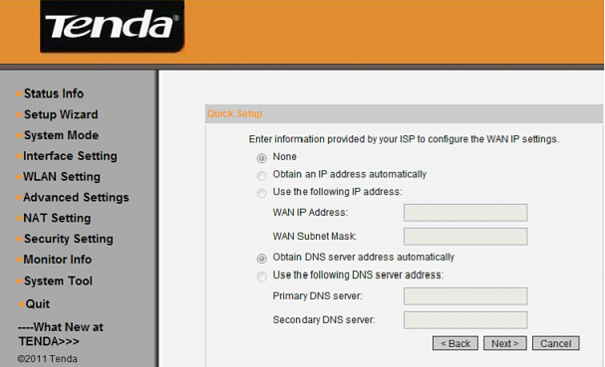
5.4 You will go to Device basic Info, please check WAN Interface Info. If WAN IP Address has been assigned, you can surf the internet now and skip to IV, or else please go to III.
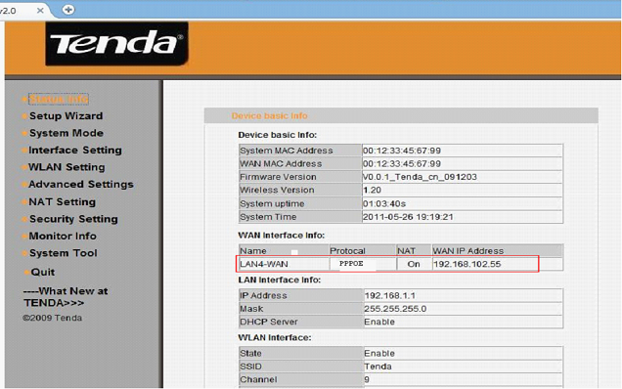
III. If the WAN IP Address shows blank or unconfigured, please try the following steps
1. Please power off your modem for a while and then turn the power back on.
2. Refresh or reload this page to check the WAN Interface Info, or go to Interface Setting then WAN settings to find if the WAN IP Address has some numbers, if it has, please go to IV.
3. Make sure the VPI/VCI, username and password are correct, as well as the internet access mode.
If the problem still exists, please contact us!
IV. Steps for wireless settings
1. Click on WLAN setting then basic setting, please change SSID (it’s the name of your wifi) to another name, only numbers or letters can be included in, and then click on confirm.
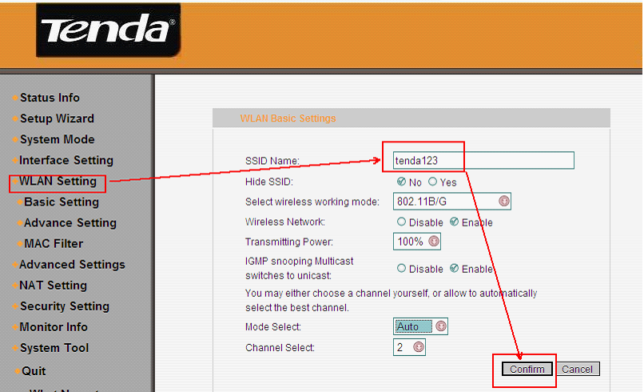
2. Click on WLAN setting then Advance setting, please select Security Options to WPA, change Select encryption protocol to AES-CCMP Protocol, choose Select Authentication Method to be PSK, and then set the security key for wifi at WPA Key Phrase (at least 8 numbers or letters). Next, go to V.
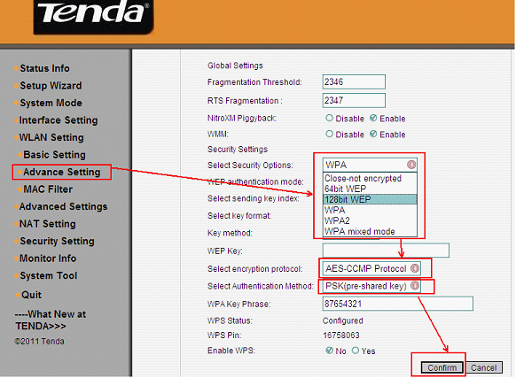
V. Connect to wireless network
1. Unplug the cable between your computer and Tenda router.
2. Find the name of your wireless network, the SSID you set it before.
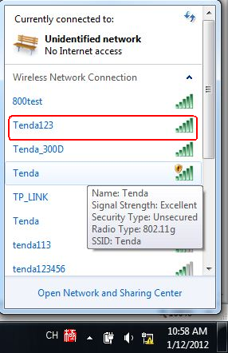
3. Type in the correct security key to connect. When it shows connected, you can use Wi-Fi now.
